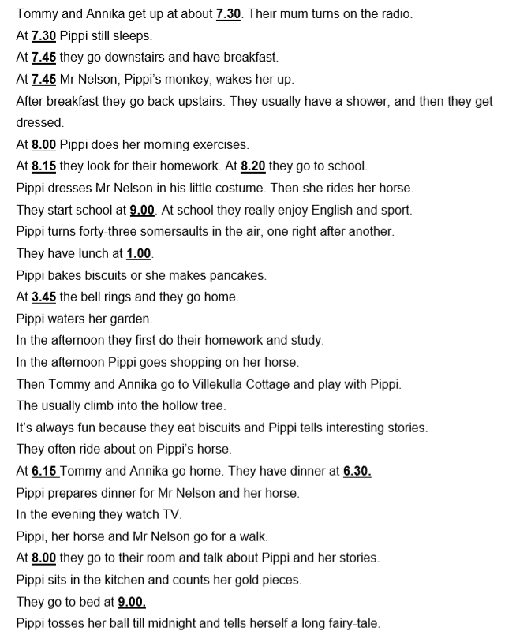
Preberi besedilo, izpiši si neznane besede, jih prevedi s pomočjo oranžnega slovarčka, na koncu pa odgovori na spodnja vprašanja.
1.When do Tommy and Anika get up? ___________________________________________
2. Who wakes Pippi up?_______________________________________________________
3. What does Pippi bake?_______________________________________________________
4. What subjects do Annika and Tommy like at school?________________________________
5. Who turns 43 somersaults in the air?____________________________________________

