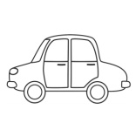
A, A, A
JAN OBIRA JABOLKA,
ANA Z NJIMI SE SLADKA.
A ___________________________________________________________

